1) Select page layout - size: A4
2) Margins:-
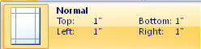
3) Font
4) Line spacing
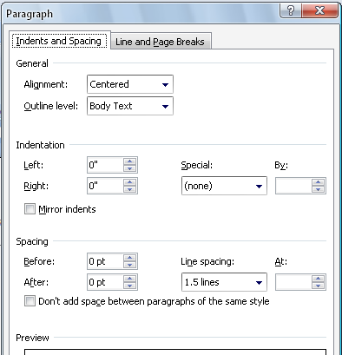
4) Then start to writing as bellow format and paper must be in two column formats starting from “Abstract”.

Title (16 Bold centre)
First Author*1, Second Author*2, Third Author*3 (11 Bold)
*1 (lecturer/student of Department, College/ University Name, Country Name) (10 Italic)
*2 (lecturer/student of Department, College/ University Name, Country Name) (10 Italic) *3 (lecturer/student of Department, College/ University Name, Country Name) (10 Italic)
Email*1, Email*2, Email*3, (10 Italic)
Up to this the line spacing is “single”at all pt”0”
PAPER MUST BE IN SINGLE COLUMN FORMAT
Start 1.5 spacing from here
Abstract (11Bold italic) : Time New Roman. (10 Italic)
Keywords (11Bold italic) –Up to five key words in alphabetical order, separated by comma (10 Italic)

INTRODUCTION (11 Bold)
Paper format font should be 10 in times new roman with 1.5 spacing (10)

Headings (11 Bold)

Subheadings (10 Bold): matter (10)

subsection with numbered1.1, 1.2, 1.3…or 1, 2, 3.OR a,b,c,d...(10 not Bold)

Indentations and EQUATIONS (11 Bold)
Matter in times new roman (10 not bold)

Figures and TABLES (11 Bold)
Figures must be computer drawn or drawn by Indian ink. Table captions appear centered above the table in upper and lower case letters. (10)

Conclusion (11 Bold)

A conclusion section (10)

Acknowledgements (11 Bold)
An acknowledgement.( 10)

References (11 Bold)
In square bracket. Or (1),(2),…….
Examples follow:
Journal Papers (11 Times new roman bold):
- Reference name (8)
Books (11 Times new roman bold):
- Reference name (8)

Matters in red color should not be appear in paper

